AI-Powered Scam Detection from Messaging Application Screenshots
Using OCR, NLP, and Machine Learning

Project Report — Related Work, System Design, Technology Stack, and Implementation Plan

Abstract
The rapid growth of digital communication platforms such as WhatsApp, Telegram, SMS, Instagram, and email has significantly increased the number of online scams, including phishing attacks, fake job offers, OTP fraud, QR code scams, banking fraud, investment scams, and delivery scams. Most existing scam detection systems rely on users manually copying and pasting suspicious text or URLs for analysis, making them inconvenient when only a screenshot of the conversation is available.
This project proposes an AI-Powered Scam Detection System that enables users to detect scams directly from messaging application screenshots without manually copying text or links. Image preprocessing improves screenshot quality, after which Optical Character Recognition (OCR) extracts textual content, Natural Language Processing (NLP) identifies scam-related language patterns, and computer vision analyzes visual elements such as QR codes, logos, and layout. The fused text and visual features are classified using Random Forest and XGBoost into one of seven scam categories, with an Explainable AI (XAI) layer providing a confidence score, risk level, reasons, and recommended safety actions.
Unlike conventional phishing detection systems that primarily analyze text, emails, or URLs, the proposed framework adopts a screenshot-first, multimodal, multi-platform approach and contributes a custom annotated messaging-screenshot dataset to address the scarcity of public datasets in this problem space.

Introduction
Scams delivered through everyday messaging platforms have grown sharply in scale and sophistication. Victims frequently encounter fraud in the form of a screenshot — a forwarded conversation, a suspicious job offer, or an OTP request — rather than as plain, copyable text. Existing scam and phishing detection research is split across narrow verticals: SMS-only spam classifiers, single-domain job-scam detectors, and website-screenshot phishing detectors that analyze browser-rendered pages rather than chat interfaces. None of these fuse text and visual analysis specifically for messaging-app screenshots across multiple scam categories.
This project addresses that gap directly by building a screenshot-first pipeline that ingests a chat screenshot from any of five platforms, extracts and analyzes both its textual and visual content, classifies it into a fine-grained scam taxonomy, and explains the decision in plain language.

Related work (last two years)
The table below summarizes the closest published work from 2024–2026 across four research clusters: OCR-based screenshot scam detection, explainable job-scam detection, webpage/phishing screenshot detection, and QR-code-specific detection.

Study | Method | Modality | Limitation
Shinde et al., 2024 (Sensors) | OCR + K-means, NMF, GMM, RNN-  Flatten, LSTM, Bi-LSTM | SMS screenshots (OCR) | SMS only; binary spam/not-spam; no scam-type taxonomy; no visual analysis
Explainable Job Scam Detection System, 2026 | TF-IDF, keyword rules, XGBoost, Logistic Regression, SHAP, OCR module | Job postings + screenshot OCR | Single domain (jobs); no computer-vision layer; OCR is a bolt-on, not core design
CrossPhire, 2026 / Phisher, 2025 / NetPhish-Mix, 2026 | URL + HTML text + webpage screenshot fusion (BERT, ResNet50, ViT) | Website screenshots | Browser-rendered webpages, not chat UIs; binary phishing/legitimate only
AI-Powered Image Analysis for Phishing Detection, 2026 | ConvNeXt-Tiny / ViT on webpage screenshots | Website screenshots (visual only) | No text fusion; websites only
Quishing Detection (Trad & Chehab), 2025 | Random Forest, LightGBM, XGBoost on QR pixel structure | QR code images only | Isolated sub-problem; never combined with conversational scam text
WhatsApp Junk Messaging Study, India | MuRIL embeddings, metadata classifiers on 2.6M messages | Raw exported text (no images) | No OCR, no screenshots, no visual scam cues

Research gap
No existing 2024–2026 work combines screenshot-native, multi-platform, multi-scam-category detection with fused text and visual analysis and built-in explainability in a single system. This project's contribution sits precisely at that intersection:
  - Screenshot-native input: chat screenshots as the primary input, not an OCR bolt-on or a browser-rendered webpage capture.
  - Platform breadth: WhatsApp, Telegram, SMS, Instagram, and email in one pipeline, versus single-platform prior work.
  - Category breadth: a seven-class scam taxonomy (Job, OTP, Banking, QR, Investment, Lottery, Delivery) versus binary classification elsewhere.
  - Text + visual fusion: OCR/NLP output combined with QR, logo, and layout analysis from the same image — a fusion that does not exist in the literature for messaging screenshots.
  - Explainability: confidence score, risk level, reasons, and recommended action, extended beyond the single-domain job-scam case into a multi-category setting.
  - Dataset contribution: a custom annotated multi-platform messaging-screenshot corpus, since no public dataset of this kind currently exists.

Objectives
- Build a screenshot-first ingestion pipeline supporting WhatsApp, Telegram, SMS, Instagram, and email.
- Apply image preprocessing to normalize screenshot quality prior to OCR.
- Extract text via OCR and analyze it using NLP for scam-related language patterns.
- Analyze visual elements (QR codes, logos, layout) using computer vision.
- Fuse textual and visual features and classify screenshots using Random Forest and XGBoost.
- Categorize detected scams into Job, OTP, Banking, QR Code, Investment, Lottery, and Delivery scams.
- Provide an explainable output: confidence score, risk level, reasons, and recommended safety actions.
- Construct and publish a custom annotated messaging-screenshot dataset.

System architecture
The system separates the user-facing application from the machine learning workload. A SvelteKit frontend handles screenshot upload and results display; a thin SvelteKit backend layer handles authentication and routing and talks to Firebase; the actual OCR, NLP, computer vision, classification, and explainability workload runs in a dedicated Python microservice, since these libraries (Tesseract, OpenCV, scikit-learn, XGBoost, SHAP) are Python-native.
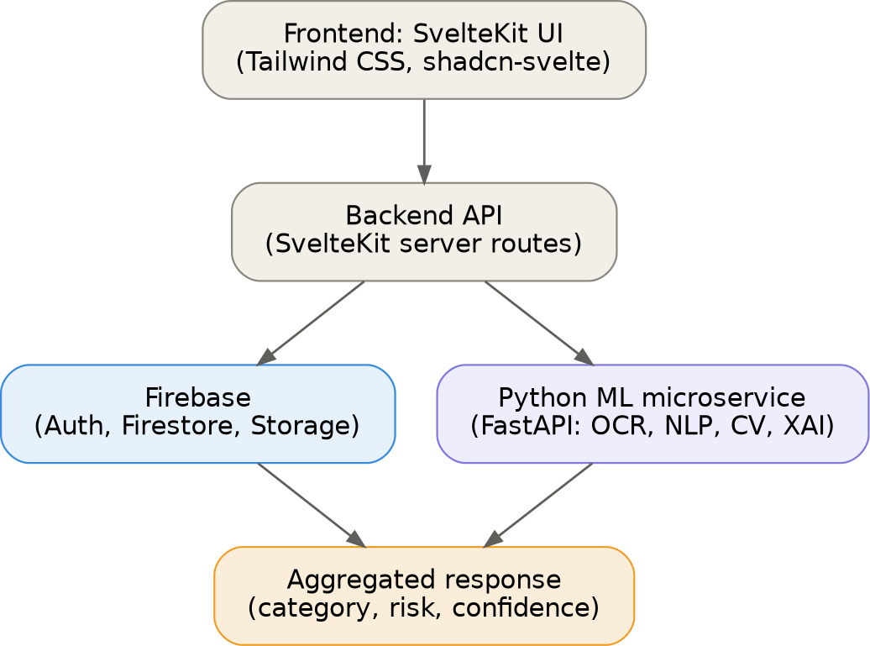

Figure 1: System architecture — SvelteKit frontend and backend, Firebase, and the Python ML microservice

Technology stack

Layer | Technology
Frontend | SvelteKit
Styling / components | Tailwind CSS + shadcn-svelte
Lightweight backend / API | SvelteKit server routes
ML / OCR / NLP / CV pipeline | Python + FastAPI (separate microservice)
Database | Firebase Firestore
File storage | Firebase Storage
Authentication | Firebase Auth
Image preprocessing | OpenCV
OCR | Tesseract OCR / EasyOCR / PaddleOCR
NLP | spaCy, NLTK, TF-IDF, Sentence-BERT
Computer vision | OpenCV, pyzbar (QR), lightweight CNN (logo matching)
ML classification | Random Forest, XGBoost (scikit-learn / xgboost)
Explainability | SHAP

Detection pipeline
Once a screenshot reaches the Python microservice, it passes through preprocessing, a parallel text branch (OCR then NLP) and visual branch (QR, logo, and layout analysis), feature fusion, ML classification, and finally the explainability layer that produces the category, risk level, confidence score, and reasons shown to the user.
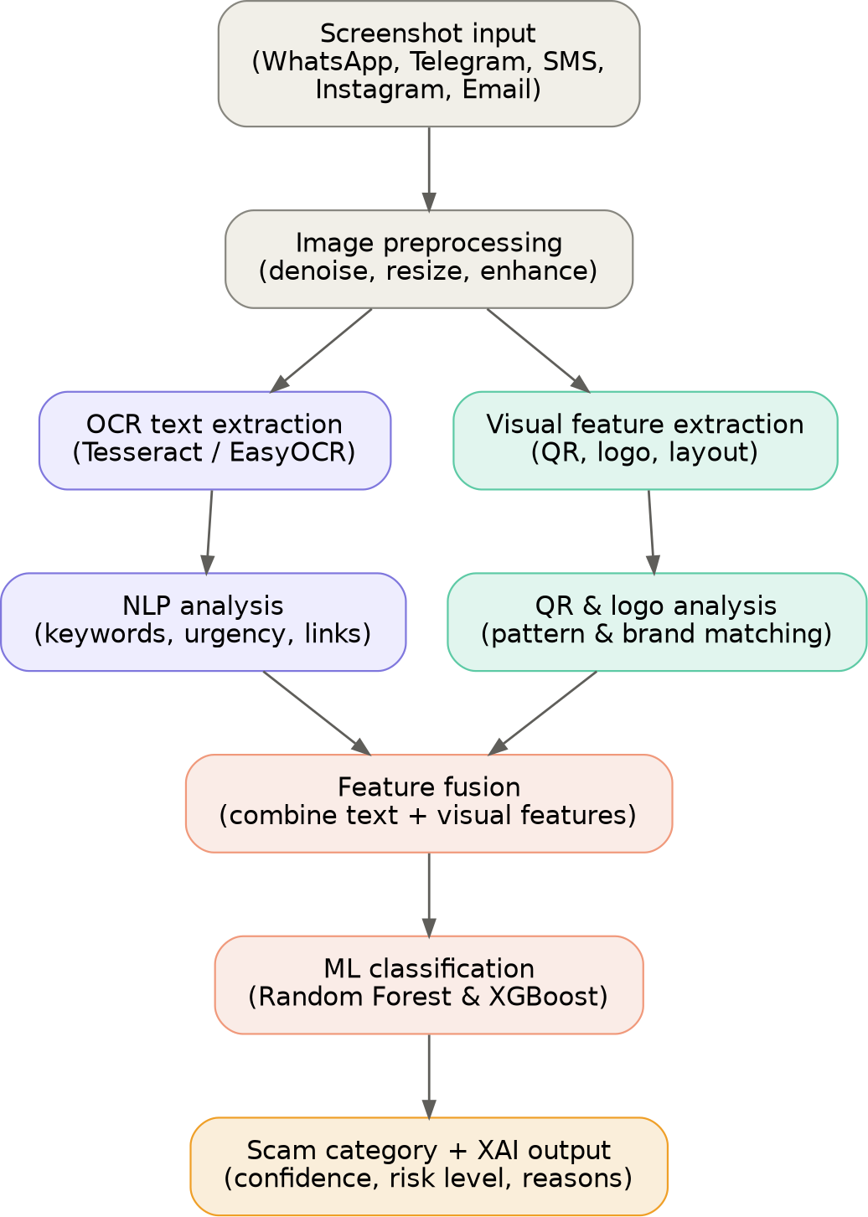
Figure 2: OCR, NLP, and computer vision detection pipeline

Implementation steps
- Project scaffolding: set up the SvelteKit project, add Tailwind CSS, install shadcn-svelte components (upload dropzone, cards, badges, alerts, tables).
- Firebase setup: configure the Firebase project, enable Auth, Firestore, and Storage; define the Firestore schema for screenshots, predictions, and users.
- Data collection and annotation: gather real and synthetic scam screenshots across the five platforms and label them by scam category and ground truth.
- Python ML microservice scaffolding: set up a FastAPI project with a /predict endpoint that accepts an image and returns structured JSON.
- Preprocessing pipeline: apply OpenCV denoising, deskewing, and contrast enhancement to maximize OCR accuracy.
- OCR integration: extract raw text with Tesseract or EasyOCR, handling multilingual and emoji-heavy chat text.
- NLP feature engineering: detect keywords, urgency phrases, financial requests, and suspicious URLs; generate embeddings.
- CV feature engineering: decode QR codes, match logos for brand impersonation, and apply layout heuristics.
- Feature fusion: merge NLP and CV feature vectors into a single structured feature matrix.
- Model training: train Random Forest and XGBoost, tune hyperparameters, and compare accuracy, precision, recall, and F1 per scam category.
- XAI layer: wrap the trained model with SHAP to generate a confidence score, risk level, top contributing features, and a recommended action.
- SvelteKit backend integration: build server routes that call the FastAPI /predict endpoint, write results to Firestore, and return a formatted response.
- Frontend integration: build the upload flow and results dashboard using shadcn-svelte components styled with Tailwind.
- Evaluation and iteration: test end-to-end on held-out screenshots, analyze misclassifications, and expand the dataset for underrepresented scam categories.

Dataset plan
Every reviewed 2024–2026 study reuses a single-purpose dataset — Kaggle Fake Job Postings, UCI SMS Spam, PhishStorm-derived QR sets, or website-screenshot benchmarks. None provides a multi-platform, multi-category messaging-screenshot corpus. This project's dataset is therefore a core research contribution, not only supporting infrastructure.

Field | Description
platform | whatsapp, telegram, sms, instagram, or email
scamCategory | job, otp, banking, qr, investment, lottery, or delivery
label | genuine or fraudulent
ocrText | text extracted from the screenshot
imageUrl | reference to the stored screenshot in Firebase Storage
annotatedBy | annotator identifier for quality tracking

Conclusion and future work
This project fills a clearly identified gap in current scam-detection research by combining screenshot-native input, multi-platform coverage, a fine-grained scam taxonomy, fused text-and-visual analysis, and explainable output in a single system, supported by a purpose-built annotated dataset. Future work includes extending the platform list, adding deep-learning-based OCR for low-quality images, exploring transformer-based multimodal fusion as an alternative to feature concatenation, and running a field evaluation with real users to measure detection accuracy and trust in the explanations provided.

References
Shinde, A., Shahra, E. Q., Basurra, S., Saeed, F., AlSewari, A. A., & Jabbar, W. A. (2024). SMS Scam Detection Application Based on Optical Character Recognition for Image Data Using Unsupervised and Deep Semi-Supervised Learning. Sensors, 24(18), 6084.
Senthuriya, C., Sindhuja, S., & Kanagadurga, N. (2026). Explainable AI Based Smart Job Scam Detection System Using Hybrid NLP & Behavioural Features. International Journal of Creative and Open Research in Engineering.
CrossPhire: Benefiting Multimodality for Robust Phishing Web Page Identification. (2026). Applied Sciences, MDPI. Phisher: A Multimodal Approach for Phishing Detection. (2025). ResearchGate preprint.
Mohammad, A. (2026). NetPhish-Mix: A Multi-Modal Phishing Detection Method Utilizing URL Graphs and Page Screenshot Vision Transformer. Engineering, Technology & Applied Science Research, 16(1).
AI-Powered Image Analysis for Phishing Detection. (2026). arXiv:2604.13555.
Trad, F., & Chehab, A. (2025). Detecting Quishing Attacks with Machine Learning Techniques Through QR Code Analysis. arXiv:2505.03451.
Jettisoning Junk Messaging in the Era of End-to-End Encryption: A Case Study of WhatsApp. University of Surrey NetSys dataset and paper.

